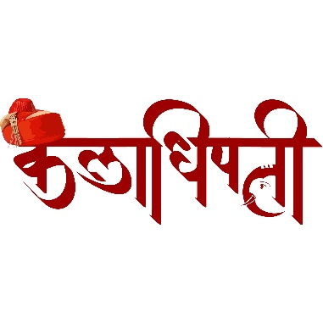
- This Exhibition and Competition is open for all photographers.
- Important Dates: Exhibition dates 24th January to 30th January 2021
Last date of enrolling: 20th January 2021
Last date of the submitting photos: 20th January 2021
Exhibition fees should be received by 22nd January 2021
- Exhibition Venue: Balgandharva art gallery, Jhansi Rani Laxmibai Chowk, Shivajinagar, Pune, Maharashtra 411005,
- Topics: Pre & Post
Participant can send maximum 12 photos for selection process. Participants are requested to send at least one photo from each topic. So, they can showcase their creativity before Selection Panel (Selection process describes briefly below).
- Guideline to send photos:
  - Participant need to send their photos at starwinsentertainment@gmail.com
  - Photos should be of minimum 300 dpi, resized in 2:3 ratio.
  - Photographs which have been displayed in our previous exhibitions should not be submitted for this exhibition.
  - Photographs should not have any border or watermark on them.
  - Digital Manipulation Allowed: - Levels Adjustment, limited cleaning, sharpening, contrast correction, minor burning and dodging. Ensure that while applying such techniques the essence of photographs is not lost. The treatment should not look jarring or artificial.
  - Not allowed:- HDR images, adding and removing elements from photograph and stitching multiple images.
  - We take the term “Copyright” seriously. The participants guarantees, that he/she owns the copyrights for every one of the submitted photographs.
- Selection panel will entertain only those photos which are relevant to topics as mentioned above. Photos will be evaluated on the basis of creativity, techniques and uniqueness.
- Selection process may take for 4-7 days, from the date of the submission of photos, each participant will be notified about the selection process by phone call or email, informing about selection/non-selection of their photos.
- All participants for exhibition will be winner as they have qualified the selection process. Each participant will have exciting offer and promo codes from our online partners.
- However, 2 outstanding photographs among the exhibited photos will be selected from each category as winners, prize winners will receive prizes decided by the organizers. Judges decision will be final.
- Exhibition fees: 300 INR per photo for exhibition. Sending photos for selection won’t cost any fees. Participant will only have to pay for the selected photos by our Selection panel (Fees can be paid via bank transfer (NEFT), Paytm and cash.(Details will be shared once your photos are qualified).
- Participants can sell their photos at the exhibition if they wish to. Organizers will charge 15% commission on the sale price of photographs sold at the exhibition.
- Photographs selected for the exhibition may be used for promotion and advertising of the exhibition by the organizers.
- All participants requested to collect their photographs and prizes from the venue at the end of the exhibition on 30th January 2021 before 8:00 pm . Participants enable to visit venue, drop an email to us with your postal address before 29th January 2021, belongings can be couriered (Charges applies).

